

Software Engineering Department
Ort Braude College

Capstone Project Phase B

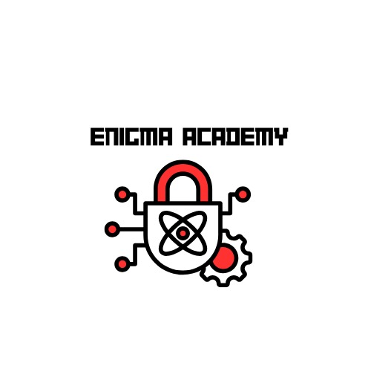
Enigma Academy

25-1-D-8

Team members:
Abed Ellateef Zoabi
Firas Amaria

Advisor:
PhD. Sulamy Moshe

GitHub - Repository
Contents – revisit after changes

1. Introduction 5
2. Related Work 6
2.1 Educational Games for Cryptography 6
2.1.1 CryptoClub 6
2.1.2 Cypher 6
2.2. Unity and Learning 7
2.3. Research on Game-Based Learning 7
2.3.1. GBL Example: Variant Limits 7
2.4. Building on What Exists 7
3. Background 8
3.1. Cryptography 8
3.1.1. Types of Cryptographic Techniques 8
3.1.2. Cryptographic Tools We Will Focus On 9
3.1.3. Real-World Applications of Cryptography 9
3.1.4. Key Concepts in Cryptography 9
3.2. Visual Learning 10
3.2.1. Visual Learning in Educational Games 10
3.2.2. Visual Learning Techniques We Used 10
3.2.3. Cognitive Benefits of Visual Learning 10
3.3. Unity Engine 11
3.3.1. 2D Game Development 11
3.3.2. Scripting and Logic 11
3.3.3. Community Support and Resources 11
4. Development process 12
4.1. System Architecture 14
4.2. Game Scenes and Flow 16
4.3. Cipher System Implementation 19
4.4. Challenges and Solutions 20
4.5. Testing and Evaluation 22
5. User Manual 23
6. Developer Guide 25
6.1. Running the Game in Unity 25
6.2. Project Folder Structure 26
6.3. Key System Folders 27
6.3.1. Scripts 27
6.3.1. StreamingAssets 29
7. Results and Reflections 30
8. References – after we get first approve - revisit 31

Abstract

"Enigma Academy" is an innovative single player, 2D game designed to demystify and teach cryptographic principles through interactive gameplay. Developed in Unity, this educational tool merges game-based learning with practical cryptographic scenarios to enhance user engagement and retention of complex concepts. Players progress through increasingly challenging puzzles, where they must decrypt messages using various cryptographic tools that they discover and learn to use within the game environment. Each puzzle integrates theoretical knowledge and practical application, ensuring that players not only understand but also apply their knowledge in simulated real-world scenarios. The game's unique approach includes a flexible inventory system where players can store and interact with texts and tools, a dynamic tutorial system that explains the functionality of each new tool in real time, and an achievement system that rewards players for their progress and mastery of cryptographic techniques. By the end of the game, players are expected to have a foundational understanding of key cryptographic methods and their applications, preparing them for further study or practical use in digital security.

1. Introduction

In today’s digital world, securing information is more critical than ever. Cryptography plays a vital role in protecting data privacy, authentication, and national security. However, the field remains difficult for newcomers due to its abstract nature and steep learning curve.

Enigma Academy is a 2D single-player puzzle game built in Unity, designed to make cryptography accessible through visual learning and interactive gameplay. By solving progressively challenging puzzles, players learn and apply real cryptographic techniques in a fictional academic setting.

The game is structured around three distinct rooms, each functioning as a level. Players must explore the room, collect encrypted “books,” and decipher them using built-in cipher tools. Each room concludes with a door puzzle that can only be solved by applying the knowledge gathered from the books. The first room introduces core concepts in a guided tutorial format, while the second and third rooms increase in difficulty, requiring more critical thinking and tool application.

The game currently supports three types of classical ciphers—including Caesar, Rail Fence, and Vigenère—with plans to expand. While still under active development, a working prototype of the first room has been implemented and tested on a local PC within the Unity environment. The prototype demonstrates core mechanics such as text storage, cipher application, room navigation, and UI interaction.

Enigma Academy aims to bridge the gap between theoretical cryptography and real-world intuition. By allowing players to learn by doing, the game encourages exploration, experimentation, and understanding—without the pressure of formal instruction.

2. Related Work
The use of games to help people learn has become more popular, especially for teaching complex subjects like cryptography. This section looks at similar projects, exploring how they combine gaming with education and comparing their methods to what we're doing in "Enigma Academy”.

2.1 Educational Games for Cryptography
Several games teach cryptography through puzzles and secret message challenges, such as CryptoClub and Cypher, which introduce basic techniques to young learners. Enigma Academy goes further, offering more complex challenges and diverse encryption methods, making it suitable for both younger and older audiences.

2.1.1 CryptoClub
CryptoClub [1] is a web-based educational platform targeting middle school students. It introduces basic encryption techniques through standalone activities and puzzles. The learning content is simple and accessible, focusing on substitution and Caesar ciphers in a playful way.
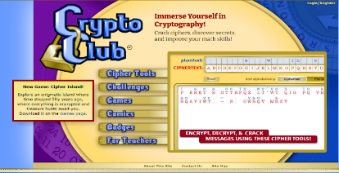
In contrast, Enigma Academy is designed for older students and learners seeking deeper engagement. It embeds puzzles directly into gameplay and uses progression-based difficulty to enhance understanding. While CryptoClub offers fragmented tools and exercises, Enigma Academy provides a unified experience where narrative, puzzles, and learning are seamlessly connected.

2.1.2 Cypher
Cypher [2] is a 3D puzzle game exploring historical cryptography. It offers over 40 cipher-based challenges inspired by historical encryption methods, each housed in a different museum-like room. The game presents complex challenges but lacks structured pedagogy or in-game learning support.
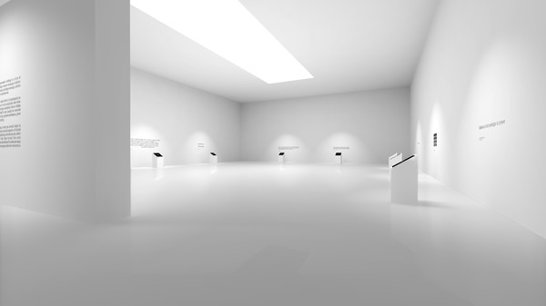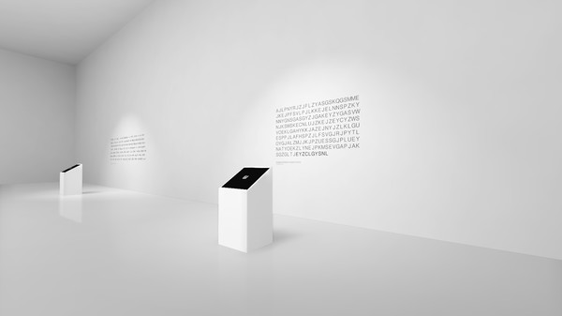
Compared to Cypher, Enigma Academy focuses more on guided discovery. It teaches players cryptographic tools (like Caesar and Vigenère ciphers) through intuitive, visual interactions. The difficulty curve is smoother and more intentional, ensuring that players build on their knowledge over time instead of being dropped into deep puzzles without preparation.

2.2. Unity and Learning
Unity is one of the most widely used engines for educational games, offering a balance between flexibility, interactivity, and ease of deployment. Projects like CodeCombat and LightBot [3] use Unity to teach programming logic through game mechanics. Enigma Academy takes a similar approach, using Unity's 2D tools, custom UI components, and interactive animations to deliver a learning experience that is immersive and accessible.

2.3. Research on Game-Based Learning
Research shows that well-designed educational games can significantly improve learning outcomes. James Paul Gee [5] and Marc Prensky [6] emphasize how games support cognitive development through engagement and active problem-solving. Douglas B. Clark et al. [7] conducted a meta-analysis confirming that educational games are most effective when gameplay mechanics align with instructional goals.
Enigma Academy is built around this principle. The game’s design ensures that learning is part of the challenge, with players applying cryptographic tools in progressively harder situations. The narrative, mechanics, and educational goals are tightly integrated to maximize impact.

2.3.1. GBL Example: Variant Limits
Variant: Limits is a 3D educational game developed by Texas A&M University to help students master calculus concepts such as limits, asymptotes, and infinity. Through a visually immersive environment, players solve calculus-based puzzles to progress in the game’s narrative.
The game has demonstrated strong educational impact—students who played it showed improved performance in calculus exams and reported better conceptual understanding. Its success highlights how game-based learning can effectively teach abstract subjects through interactive and visually driven experiences.
Like Enigma Academy, Variant: Limits shows that educational games can go beyond memorization and foster real problem-solving skills in complex domains.

2.4. Building on What Exists
Many educational games are designed for young learners and focus on basic skills [10]. However, there is a growing need for games that teach more advanced concepts in an engaging way. Most existing titles do not offer the depth, challenge, or real-world relevance that Enigma Academy provides. This game fills that gap by combining progressive difficulty, hands-on interaction, and real cryptographic techniques—offering players a learning experience that goes beyond theory and mirrors practical applications.

3. Background
This section is dedicated for the description of term, algorithms and methods used in this project

3.1. Cryptography
Cryptography is the science of securing information through encoding and decoding. It ensures confidentiality, integrity, and authenticity of data [11], protecting it from unauthorized access. From classical ciphers like Caesar to modern encryption algorithms, cryptography plays a central role in online privacy, secure communication, and digital systems [12].

3.1.1. Types of Cryptographic Techniques
Cryptographic techniques can be categorized into the following types:
1. Substitution Ciphers:
    - Replace each letter in the plaintext with another letter based on a specific rule.
    - Examples:
      - Caesar Cipher: Letters are shifted by a fixed number of positions.
      - Monoalphabetic Cipher: A more complex substitution where each letter maps to a unique replacement.
2. Transposition Ciphers:
    - Rearrange the order of characters in plaintext without altering the letters themselves.
    - Examples:
      - Rail Fence Cipher: Text is written in a zigzag pattern and read row by row.
      - Columnar Transposition Cipher: Text is written into rows and read by columns based on a keyword.
3. Polyalphabetic Ciphers:
    - Use multiple substitution alphabets to encrypt the message.
    - Examples:
      - Vigenère Cipher: Employs a keyword to define shifts for each letter.
4. Modern Cryptographic Techniques (Not used in the game but noteworthy):
    - Symmetric Encryption: Uses the same key for both encryption and decryption (e.g., AES).
    - Asymmetric Encryption: Uses a public-private key pair for secure communication (e.g., RSA).

3.1.2. Cryptographic Tools We Will Focus On
In "Enigma Academy," players will use the following tools to solve cryptographic puzzles:
- Caesar Cipher:
  - A simple substitution cipher where letters are shifted by a fixed number.
  - Introduces players to basic encryption and decryption concepts.
- Vigenère Cipher:
  - A polyalphabetic substitution cipher that uses a keyword for encryption.
  - Highlights the importance of keys in cryptography.

3.1.3. Real-World Applications of Cryptography
Cryptography is an essential component of modern technology, with applications such as [13]:
- Secure Communication: End-to-end encryption in messaging apps like WhatsApp and Signal.
- Online Transactions: Protecting sensitive information during online purchases with SSL/TLS.
- Blockchain Technology: Ensuring data integrity and security in cryptocurrency systems.
- Authentication: Verifying identities with digital signatures and certificates.
These applications underscore the real-world relevance of cryptographic techniques, connecting the educational goals of "Enigma Academy" to practical uses.

3.1.4. Key Concepts in Cryptography
Keys: A key is used to encrypt and decrypt data. It can be shared (symmetric) or kept private (asymmetric).
Plaintext and Ciphertext: Plaintext is the original message, while ciphertext is the encrypted version.
Encryption and Decryption: Encryption secures data, and decryption restores it to its original form.
Algorithms: Mathematical formulas used to transform plaintext into ciphertext and vice versa.

3.2. Visual Learning
Visual learning enhances comprehension and retention by using interactive visuals, animations, and hands-on engagement [14]. It is particularly effective for students who struggle with abstract concepts, as it simplifies complex ideas into tangible visuals. Studies show that digital game-based learning significantly improves educational outcomes when designed effectively [7]. In Enigma Academy, this approach is central, as players solve cryptographic puzzles through immersive and visually guided gameplay.

3.2.1. Visual Learning in Educational Games
Educational games effectively utilize visual learning by combining interactive elements with engaging visuals [7]. Games can simplify challenging subjects by using animations, progress trackers, and interactive feedback systems.
In "Enigma Academy", real-time visual transformations help players understand encryption and decryption mechanics. This combination of visual feedback and hands-on engagement ensures that learning feels natural and enjoyable [15].

3.2.2. Visual Learning Techniques We Used
Interactive Gameplay:
- Players interact with glowing objects, inventory items, and puzzle-solving interfaces, guiding their attention to key elements [14].
Dynamic Inventory System:
- The inventory resembles an open book, where encrypted and decrypted texts are displayed side by side, allowing players to compare and analyse transformations visually [15]. Players are able to save any text they find in the game; they can even save decrypted texts after they use the cryptography tools in the inventory.
Puzzle Interfaces:
- Each puzzle offers a unique visual design, allowing players to experiment with tools like the Caesar Cipher or Vigenère Cipher. The interface provides immediate feedback, showing how each tool transforms the text [7].

3.2.3. Cognitive Benefits of Visual Learning
Visual learning stimulates cognitive functions such as problem-solving, critical thinking, and creativity [14]. By encouraging players to experiment with cryptographic tools in a visually guided environment, "Enigma Academy" fosters active learning and exploration. The ability to observe and manipulate data interactively helps players build connections between cryptographic principles and real-world applications, making the educational experience both immersive and impactful [15].

3.3. Unity Engine
Unity is a cross-platform game engine widely used for developing 2D and 3D games. Known for its flexibility and robust feature set, Unity provides tools for physics simulation, scripting, and asset management, making it an ideal choice for creating educational games [4].

3.3.1. 2D Game Development
Unity’s 2D capabilities allow for the creation of top-down room layouts, character movement, and interactive objects. This simplifies the development of environments and gameplay mechanics.

3.3.2. Scripting and Logic
The engine’s scripting capabilities, powered by C#, enable the implementation of complex systems like dynamic inventory, puzzle validation, and room transitions. Unity’s modular architecture ensures that these systems are scalable and maintainable [16].

3.3.3. Community Support and Resources
Unity's asset store provides access to pre-built components and assets, accelerating the development process. Additionally, the extensive community support ensures developers have access to tutorials, forums, and tools, which are invaluable for resolving challenges and expanding the game [17].

4. Development process
The development of Enigma Academy was carried out using the Unity game engine, with C# as the primary scripting language. Our team followed an iterative, modular approach, focusing on one major feature at a time while ensuring integration between systems. The game was designed as a 2D single-player experience, consisting of three rooms of increasing difficulty. Each room required the player to solve cryptographic puzzles to unlock progression, using tools and knowledge acquired during gameplay. Development was completed and tested on a local PC environment.

Main Menu
We began development by building the main menu, which serves as the player's entry point into the game. Designed using Unity’s UI system, the menu allows players to start the game, access basic settings, or exit. The layout is clean and responsive, ensuring a smooth transition into gameplay. From here, the player enters Room 1 to begin the educational experience.

Room 1 – Core Gameplay Foundation
Room 1 served as the foundation for developing the game’s main mechanics. It was constructed using Unity’s Tilemap system, which allowed us to create a detailed and interactive environment filled with elements like bookshelves, drawers, and other puzzle-related objects. We implemented player movement using a custom movement script, combined with an Animator Controller to handle walking animations. A pause menu was also introduced at this stage, allowing the player to temporarily pause gameplay and access options.

Inventory System
The inventory system plays a central role in the game by allowing players to store, review, and interact with texts they discover throughout the rooms. It is accessible at any point during gameplay and persists across all scenes. The interface resembles an open book: the left page displays saved texts while the right page holds the cryptographic tools the player has unlocked. Players can select text from their inventory, apply cipher tools, and save the resulting decrypted messages for future use.

Book Database Manager
To support dynamic content, we developed a Book Database Manager that stores and organizes all encrypted texts in the game. This component manages which books are shown based on the player’s progress and room context. When a player finds a book in the environment, it is added to the inventory through this system. This manager ensures that all data is properly fed to the Book Reader UI and supports clean text retrieval throughout the game.

Book Reader UI
The Book Reader UI was designed to let players view and manipulate encrypted texts. It includes a scrollable input area, an output area for decrypted text, and a text selection feature that allows players to apply cryptographic tools to specific parts of a message. Built using nested RectTransform components and anchored UI elements, the interface is responsive across different resolutions and screen sizes. It integrates seamlessly with the inventory system and supports real-time interaction with the cipher logic.
Room Transitions
To enable smooth navigation between rooms, we implemented a custom scene transition system using GameObjects called RoomMove. These are placed near exits or doors, and when triggered, they load the next scene while preserving player state, progress, and inventory data. This mechanic allows players to advance from Room 1 to Room 2 and Room 3.

Room 2 and Room 3
After establishing the mechanics in Room 1, we developed Room 2 and Room 3 using the same structural base. These rooms introduce increased difficulty through more complex puzzles and deeper integration of cryptographic concepts. Each room contains new texts, hidden clues, and room-specific challenges. The structure reinforce the learning-through-play philosophy of the game.

Door Puzzle System
Each room concludes with a door puzzle, which acts as the final challenge. The player must decipher clues from the books they’ve collected to unlock the door using a dedicated input system. This UI accepts alphanumeric entries and compares the input to the solution derived from the room’s encrypted content. Once the correct answer is submitted, the door opens, allowing the player to proceed to the next level or finish the game.

User Experience and GUI
To support new players, we developed a built-in tutorial system that appears as a guided GUI in Room 1. This interface provides step-by-step instructions on interacting with books, using cipher tools, and solving the door puzzle. It was designed to be clear and non-intrusive, ensuring a smooth learning curve while maintaining a clean, readable layout using Unity’s UI tools.

Finalization and Testing
After all major features were implemented, we polished the visuals, refined transitions, and fixed known bugs. We tested the prototype locally in the Unity Editor to validate functionality, check inventory consistency, and confirm puzzle mechanics. The final build successfully demonstrates core gameplay and educational goals, completing the game’s primary development cycle.

4.1. System Architecture
The architecture of Enigma Academy was designed with modularity in mind to ensure flexibility, ease of debugging, and support for future expansion. The project is built entirely in Unity, using C# scripts to manage both gameplay logic and user interaction. Core components such as the inventory system, book database, cipher tools, and scene transitions were structured as independent, reusable modules.

Core Game Flow
The game begins at the main menu and guides players through a sequence of rooms, each containing puzzles of increasing difficulty. Within each room, players interact with books to uncover encrypted texts. These texts are sent to built-in cipher tools, where players perform encryption and decryption. Once a correct result is discovered, players input the answer in the puzzle UI, triggering a transition to the next room.
The game is fully offline and handles all logic internally—no client-server architecture is used.

System Layers
- User Interface Layer: Handles menus, puzzle panels, book readers, inventory displays, and cipher tools. It supports responsive layout and is accessible across scenes.
- Gameplay Logic Layer: Manages player movement, interaction detection, puzzle validation, and game rules. Logic is abstracted into managers that coordinate how text selection, ciphering, and puzzle solving operate.
- Data Handling Layer: Uses JSON files for books, saved texts, and player progress. These files are read at runtime and updated as the player unlocks content or completes rooms.
- Scene Management Layer: Each room is built as a separate scene. Transitions are triggered by in-game interactions and retain game state across scenes through persistent managers.

1. User Interface (UI) Layer
This layer is responsible for all user-facing elements of the game. It includes panels, menus, and input fields that let players interact with the game's mechanics.
Includes:
- Main Menu: Start, quit, and navigation options.
- Inventory UI: Displays collected books, lets players open/read them.
- Book Reader Panel: Scrollable text display + cipher tool integration.
- Cipher Tool Panel: Dropdown to select cipher, input for keys, output area.
- Door Puzzle Interface: Input field for password-based progression.
- Saved Notes Panel: Displays player-saved decrypted content.
Key Feature:
All UI elements are responsive and reusable across scenes. The interface is modular—each panel has a clearly defined purpose and can be opened or hidden independently.

2. Gameplay Logic Layer
This layer manages core game mechanics like player movement, interaction with objects, room transitions, and cipher execution.
Includes:
- Movement and animation: Handles WASD input, movement lock when UI is open.
- Interaction detection: Enables player to interact with books, doors, UI triggers.
- Cipher Execution Logic: When a player selects a cipher and presses the "Decrypt" button, logic validates and processes the text.
- Progression triggers: Detects when puzzles are solved and initiates transitions.
Key Feature:
Logic is split across systems to keep concerns separate. For example, the puzzle system never touches movement code. Everything is loosely coupled but fully integrated.

3. Data Handling & Persistence Layer
This layer deals with all game data management — both static (book content) and dynamic (player progress).
Includes:
- books.json: Contains all encrypted texts and metadata (ID, title, content).
- progress.json: Stores which room the player is in, unlocked books/ciphers, and viewed hints.
- savedtexts.json: Stores decrypted texts manually saved by the player.
- Data Loaders: Scripts that parse JSON files at runtime and populate in-game systems.
Key Feature:
Using plain JSON and StreamingAssets enables easy editing and updating of game content without modifying code.

4. Scene Management Layer
This layer handles room transitions and scene loading, ensuring a seamless game experience.
Includes:
- Room Scenes: Each room is built in a separate Unity scene.
- Triggers: In-game colliders signal when a room is cleared and ready to change.
- Persistent Managers: Key systems like UI and progress remain active across scene loads using Unity’s “Don’t Destroy on Load”.
Key Feature:
Scenes are modular. Each can be designed/tested independently and loaded dynamically based on player progression.

4.2. Game Scenes and Flow
Main Menu
The game opens with a main menu scene, where players can start a new session or exit the application. This screen is built using Unity’s UI system and sets the tone with a minimalist, academic visual theme. From here, the player transitions into Room 1.
<add picture: screenshot of the main menu with start and exit buttons>

Room 1 – Tutorial and Introduction
Room 1 introduces the player to the game world and basic mechanics. The room layout is created using Unity’s Tilemap system and contains interactive elements such as bookshelves, containers, and environment objects. Players can move freely, discover books, open their inventory, and use cipher tools. A built-in tutorial GUI provides guidance on how to interact with texts and use the decryption interface.
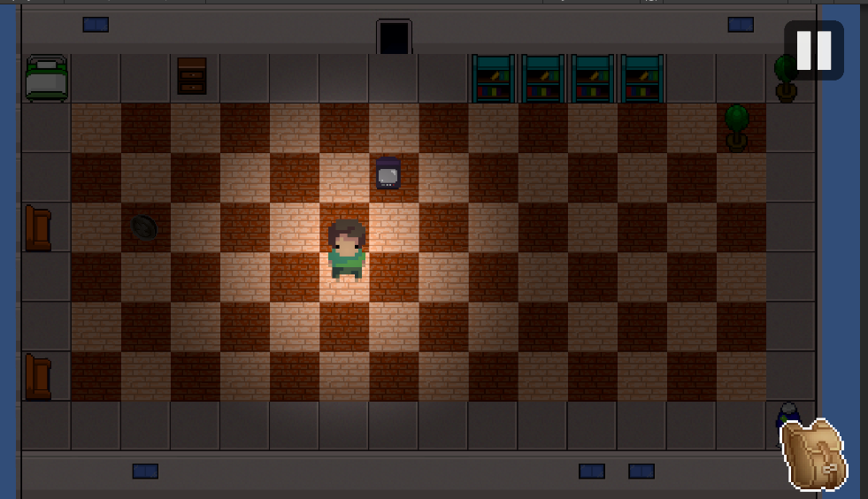
(Picture 1 : Room 1 scene)
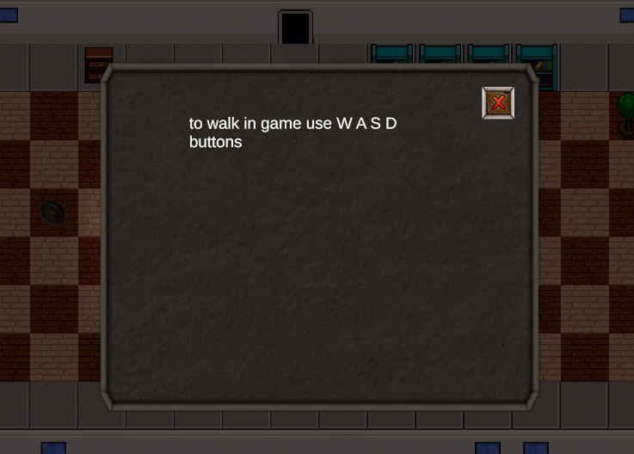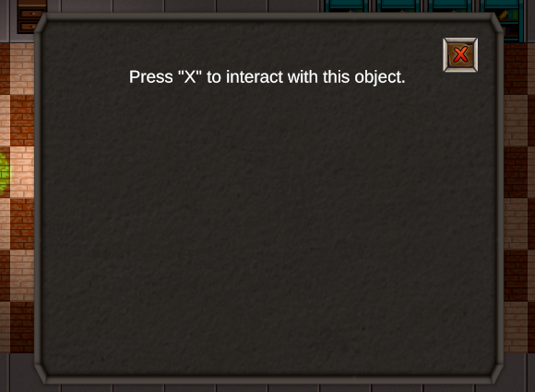
(Picture 2 : Guide UI Examples)

Book Interaction
In each room, players encounter encrypted books placed in the environment. When a player interacts with a book, its content is added to the inventory and becomes available through the Book Reader UI. From there, players can analyze, select, and apply cipher tools to try and uncover the solution.
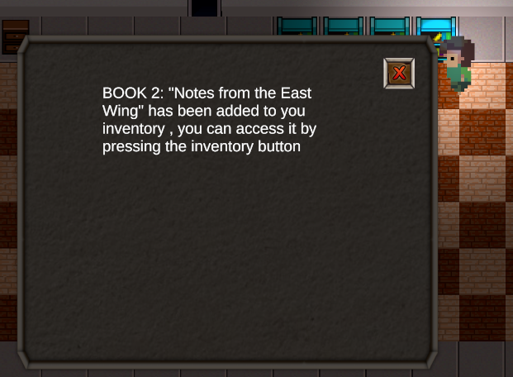
(Picture 3 : Interaction With a Bookshelf Result)

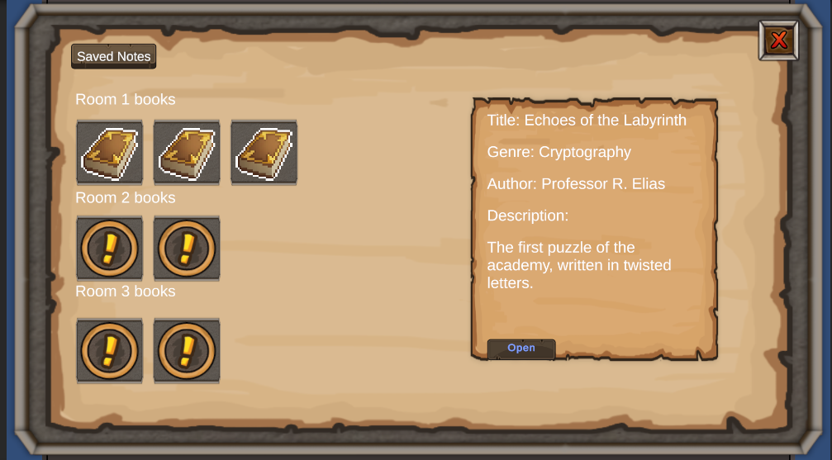
(Picture 4 : Inventory UI , showing Found Books for each Room and small Discription)
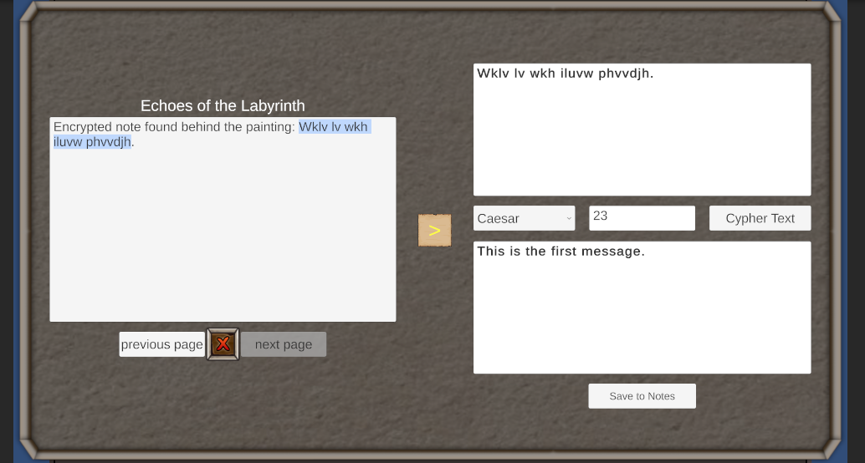
(Picture 5 : Book View UI , can be view when opening a book from the main inventory UI)

Room 2 – Intermediate Puzzles
Room 2 builds on the player’s understanding of the game by introducing longer and more complex encrypted texts. This room encourages revisiting previously collected information and applying multiple cipher tools. Puzzle difficulty is increased not only through the content but also through the way clues are hidden in the environment.
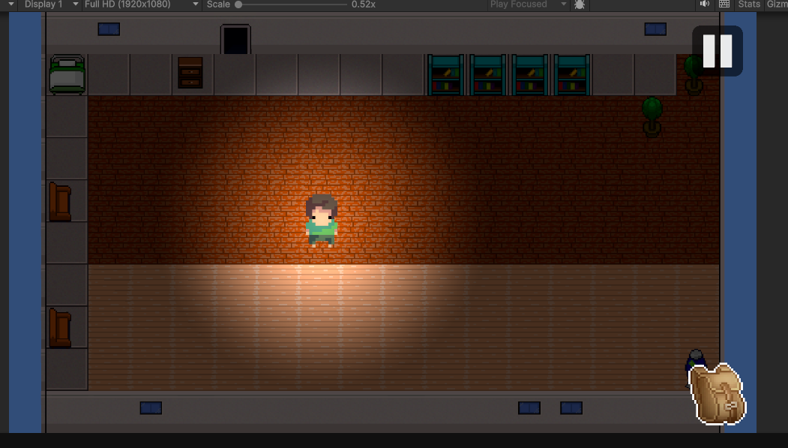
(Picture 6 : Room 2 scene)

Room 3 – Final Challenge
Room 3 represents the most difficult level. Players must combine different cipher techniques, connect patterns between multiple texts, and apply logical reasoning to solve the final puzzle. Clues may be split between texts found in different rooms, requiring the player to use previously saved decryptions and revisit their notes.

(Picture 7 : Room 3 scene)

Door Puzzle System and Game Progression
Each room ends with a locked door that requires the player to input a correct solution derived from the decrypted content. This is done through a custom UI input system that accepts letters, numbers, or symbolic answers. A successful input unlocks the next room or, in the case of Room 3, completes the game and triggers the graduation ending.
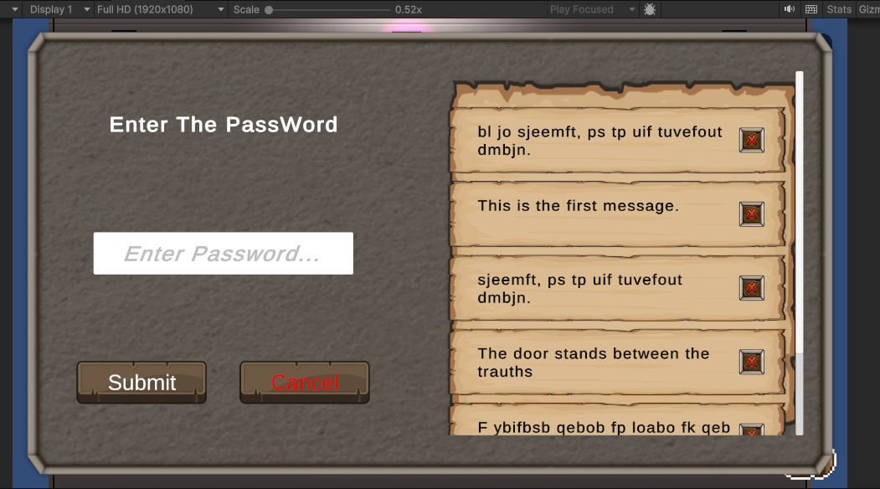
(Picture 8 : Door Puzzle UI: you can view saved notes to help with puzzle )

4.3. Cipher System Implementation
The cipher system is the core mechanic that transforms Enigma Academy from a narrative puzzle game into an educational experience in cryptography. It allows players to apply classical ciphers to encrypted texts found throughout the rooms in order to uncover hidden messages and progress through the game.

Each cipher is implemented as a modular component that connects with the Book Reader UI. When the player selects a portion of text from a saved book, the selected string is passed into the cipher interface, where they can choose a cipher type and enter a key or shift value. Upon clicking the cipher button, the result is displayed in a dedicated output field. The player can then choose to save this decrypted message in their inventory for later reference.

The first implemented cipher is the Caesar cipher, which shifts letters by a user-defined amount. This system validates input, ignores unsupported characters, and handles both encryption and decryption modes depending on the player's choice. The system was designed to be extensible, allowing additional cipher types—such as Rail Fence and Vigenère—to be integrated using the same UI logic and backend structure.

To ensure clarity and usability, the cipher interface was placed alongside the Book Reader panel. The layout includes a dropdown menu for cipher selection, an input box for keys or shifts, and a large, scrollable area for both original and processed texts. All components were built using TextMeshPro and anchored properly for responsiveness across different screen resolutions.

This system not only supports gameplay but also reinforces cryptographic learning by encouraging experimentation. Players can try multiple approaches and immediately see how different keys affect the text, deepening their understanding of how classical ciphers work.

(Picture 5 : Book View UI , can be view when opening a book from the main inventory UI)

4.4. Challenges and Solutions
During the development of Enigma Academy, we encountered several technical and design-related obstacles that required creative and practical solutions. This section highlights some of the key challenges we faced and how we addressed them to ensure a smooth gameplay and learning experience.

Challenge:
Creating a scrollable, interactive Book Reader UI that supports text selection and dynamic resizing.
Solution:
We replaced Unity’s default InputField with TextMeshPro components and manually structured the UI using RectTransform and vertical layout groups. This gave us full control over layout behavior, allowed proper text wrapping, and supported both user interaction and consistent visual formatting.

Challenge:
Designing a flexible cipher system that could handle multiple types of ciphers without rewriting the UI for each one.
Solution:
We developed a centralized cipher manager that communicates with the UI via a dropdown menu and unified input/output fields. Each cipher is implemented as a separate module, and the manager handles which module to call based on user selection—allowing seamless integration of new cipher types like Vigenère or Rail Fence.

Challenge:
Preserving inventory data and player progress when transitioning between scenes.
Solution:
we added a Json file that will save progress of the player, this includes what rooms they are in, what books they found, what doors they unlocked, what ciphers did they find, this Json file will also help with the tutorial room and which GUI we showed and didn’t show.

Challenge:
Players did not immediately understand how to use the cipher system or interpret the puzzles during initial tests.
Solution:
We added a visual tutorial system in Room 1 that introduces key mechanics step-by-step. The tutorial GUI explains how to open books, use cipher tools, and solve the door puzzle, providing a structured introduction with pictures to the gameplay loop.

Challenge:
Collaborating in Unity across multiple developers caused scene integration issues due to the way Unity serializes .unity scene files.
Solution:
Unity’s scene files are binary-based, making simultaneous edits nearly impossible. To avoid merge conflicts and overwriting work, we split the project into modular scenes and prefabs. Each developer worked on isolated components (e.g., inventory UI, cipher system, individual rooms) that were later integrated through prefabs and shared scripts, reducing conflict risk and supporting collaborative workflow.

Challenge:
Enhancing the cipher system with visual animations or dynamic UI feedback to make the encryption process feel more interactive and immersive.
Current Status:
While we envisioned animated effects (e.g., letters visually transforming as they're decrypted), we lacked the experience and design resources to implement them. Unity doesn’t provide built-in tools or assets for this type of cryptography-focused animation, and no suitable third-party assets were found. As a result, the system currently provides text-based input/output only. This is a key area marked for future improvement once more time and resources are available.

4.5. Testing and Evaluation
Unit-Tests: -

Test Number |  | Test Name | Description | Status
1 | test_caesar_cipher_encryption |  | Verifies that Caesar cipher correctly encrypts a given plaintext with a valid shift value. | Pass
2 | test_caesar_cipher_invalid_input |  | Ensures that entering a non-numeric or empty shift value does not crash the system. | Pass
3 | test_book_addition_to_inventory |  | Tests that interacting with a book adds the correct book object to the inventory system. | Pass
4 | test_inventory_persistence_  between_rooms |  | Validates that the inventory content remains consistent when transitioning between scenes. | Pass
5 | test_cipher_result_save_  functionality |  | Confirms that the player can save a decrypted result and access it later in the inventory. | Pass
6 | test_door_puzzle_validation_  correct_input |  | Simulates entering the correct solution in the door input UI and verifies successful unlocking. | Pass
7 | test_door_puzzle_validation_  wrong_input |  | Ensures that incorrect inputs do not trigger door progression. | Pass
8 | test_text_selection_range_  in_reader |  | Tests whether a selected portion of text is correctly passed to the cipher tool logic. | Pass
9 | test_tutorial_popup_trigger_  on_start |  | Validates that the tutorial UI activates at the start of Room 1 as expected. | Pass
10 | test_cipher_type_switching_  stability |  | Ensures that switching between ciphers in the dropdown does not reset or corrupt the UI state. | Pass

5. User Manual
Welcome to Enigma Academy
Step into a mysterious academic world where cryptographic puzzles await. Enigma Academy is a 2D single-player game that combines interactive learning with immersive gameplay. Solve encrypted books, use cipher tools, and unlock new rooms as you master the art of decryption.

System Requirements
Before launching Enigma Academy, make sure your system meets the following minimum requirements:
- Operating System: Windows 7 or newer
- Processor: Intel i3 or equivalent
- Memory: 4 GB RAM
- Graphics: Integrated or dedicated GPU with support for 2D rendering
- Disk Space: ~200 MB
- Input Devices: Keyboard and Mouse

Getting Started
Installation:
- Download the project or executable from: https://github.com/Firas-amaria/FinalProject-CryptoGame
- If you're running from Unity:
  - Open the project in Unity Hub
  - Press Play in the Unity Editor
- If using a standalone build:
  - Extract the folder and run EnigmaAcademy.exe
No registration or login is required. All progress is stored locally.

Navigating the Main Menu
When you launch the game, you will see the main menu with the following options:
- Start Game – Begin a new session in Room 1
- Settings – Adjust resolution, audio, and fullscreen mode
- Exit – Close the game
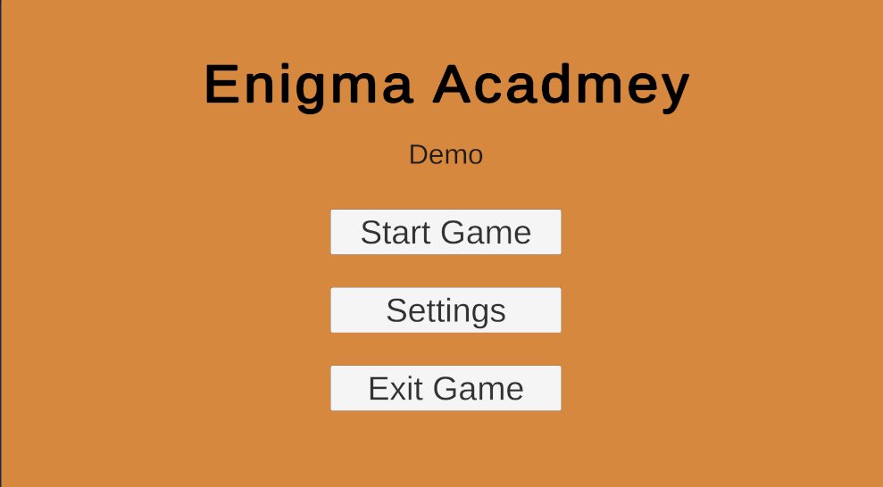
(Picture 9 : Main Menu Screen )

Game Overview
Enigma Academy consists of three rooms. Each room contains encrypted texts hidden throughout the environment. Players must collect these texts, use their cipher tools to decrypt them, and discover the password that unlocks the final door.
Each room increases in difficulty and introduces new challenges, encouraging players to think critically, experiment with cipher tools, and revisit past content to solve layered puzzles.

Game Controls and Interface
Basic Controls
- Move Player: Arrow Keys / WASD
- Interact with Objects: E or Left Click
- Open Inventory: I / on screen button
- Pause Game: Esc / on screen button
- Apply Cipher: Select text in the reader, choose tool and key, then click Cipher

(Picture 3 : Interaction With a Bookshelf Result)


(Picture 4 : Inventory UI , showing Found Books for each Room and small Discription)

In-Game Display
- Book Reader: View encrypted text and apply cipher tools
- Cipher Panel: Select tool, enter key, and view the result
- Inventory: Stores all collected and decrypted texts
- Tutorial Prompts: In Room 1, guides appear to help new players

(Picture 5 : Book View UI , can be view when opening a book from the main inventory UI)

Progressing Through the Game
Each room ends with a door puzzle that must be solved using clues from the books you've decrypted.
- Collect and decrypt texts
- Identify the solution word/code
- Enter the solution in the door input panel
- If correct, the door will open and allow you to proceed

(Picture 8 : Door Puzzle UI: you can view saved notes to help with puzzle )
Progress is automatically saved between rooms. Your inventory and tools carry over.
Conclusion
Enigma Academy offers a unique way to learn about cryptography by doing. Through interactive puzzles, carefully designed environments, and a powerful set of cipher tools, players will build a strong foundation in cryptographic thinking while enjoying a mysterious and rewarding gameplay experience.
Prepare your tools, decode the secrets, and unlock your graduation. Welcome to the Academy.

6. Developer Guide
This section is intended for developers, testers, or instructors who want to run, maintain, or expand Enigma Academy using the Unity Editor. The game was built using Unity and C#, with a modular structure that allows new rooms, books, or puzzles to be added with minimal effort. Whether you are trying to build a standalone version, update puzzle content, or contribute to the project, this guide will walk you through the essentials of working with the game at the development level.

6.1. Running the Game in Unity
To run Enigma Academy, you must open the project in the Unity Editor. This allows you to test the game, debug features, or begin development work. Below are the required tools and steps.

Prerequisites
- Unity Version: Unity 2022.3 LTS (or newer)
- Unity Hub: Installed on your system
- Optional: A Git client (if cloning the project directly from GitHub)

Steps to Open and Run the Project
- Download the Project
  - Either clone the GitHub repository:
  - https://github.com/Firas-amaria/FinalProject-CryptoGame
  - Or download the ZIP and extract it to your preferred development directory.
- Open Unity Hub
  - Click Add Project
  - Navigate to the extracted folder that contains the Assets, ProjectSettings, and Packages directories.
  - Select the folder to add it to your Unity projects list.
- Open the Project
  - Select the project from Unity Hub.
  - Unity will load all assets and compile scripts. This may take a few moments the first time.
- Select the Entry Scene
  - In the Project tab, go to:
Assets/Scenes/MainMenu.unity
  - Double-click to open the Main Menu scene.
- Play the Game
  - Press the Play button at the top center of the Unity Editor.
  - The game will start from the Main Menu, allowing you to navigate into Room 1 and begin testing gameplay features.

Optional: Running Other Scenes
- You can manually open Room1.unity, Room2.unity, or Room3.unity from the Scenes folder to test specific levels.
- The game is designed to preserve player progress and inventory across scenes when played in sequence from the Main Menu.

6.2. Project Folder Structure
To help future developers or contributors navigate the Enigma Academy project, this section outlines only the folders that are essential for editing game logic, content, or UI.

Scenes/
Contains all playable levels in the game: MainMenu, Room1, Room2, and Room3. To test or build the game, start by opening MainMenu.unity.

scripts/
Holds all C# source code for the game, including:
- Player movement
- Inventory system
- Cipher logic
- Book interaction
- Room transition scripts
This is the core folder for any gameplay or logic changes.

Prefabs/
Contains reusable GameObjects like the player, UI panels (pause menu, inventory), cipher tools, and triggers. When adding or updating functionality across rooms, work with these prefabs to maintain consistency.

StreamingAssets/
Stores all external game data:
- Book content (encrypted texts used in puzzles)
- Saved progress files
- Decrypted texts saved by the player
This is the go-to folder for adding or modifying cryptographic content without editing scenes or code.

Sprites/
Contains all image and sprite files used for game visuals: UI icons, environmental decorations, book graphics, and more.

animation/
Includes movement animation sprites and the Animator Controller that controls player animations during gameplay.

These folders are the most critical for game development and customization. Other folders (e.g., TextMesh Pro, Settings, Physics) are either automatically generated by Unity or not directly used in gameplay development, and can be safely ignored unless advanced changes are required.

6.3. Key System Folders
This section provides an overview of the two most important folders in the project: scripts/ and StreamingAssets/. These folders contain the game’s logic and dynamic data, respectively, and are the main points of interest for developers maintaining or extending Enigma Academy.

6.3.1. Scripts
The scripts folder contains all the C# files responsible for core gameplay mechanics, UI interaction, data handling, and system logic. Below is a breakdown of each script and its role in the game.

MainMenuScript.cs
This script controls the functionality of the main menu. It includes methods to:
- Start the game by loading Room 1 using Unity’s SceneManager
- Exit the game with Application.Quit() (also logs a debug message)
- Open and close the settings panel by toggling its visibility using SetActive(true/false)
This script is typically attached to a MainMenu UI GameObject and connected to button OnClick() events for "Start", "Exit", and "Settings".

PauseMenuScript.cs
This script manages the in-game pause menu. It allows the player to pause and resume the game, return to the main menu, and (optionally) access a settings panel. When paused, the pauseMenu UI is activated, and player movement is disabled by setting a static flag in the playerMovement script. Resuming reverses these actions. It also includes a placeholder method for opening an options menu. This script is usually attached to a persistent UI controller in gameplay scenes.

playerMovementScript.cs
This script handles the player’s movement, animation control, and interaction with the inventory system. It uses directional input (WASD) to move the player and sets animator parameters for walking animations. It includes logic to pause movement when the game is paused or when the inventory is open. The inventory can be toggled with the I or E keys. When the inventory is opened, the script calls OpenInventory() from the InventoryScript and sets the shared isPaused flag to prevent movement. It’s attached to the player GameObject and interacts closely with the animator and UI systems.

BookSlotScript.cs
This script is attached to UI slot elements in the inventory and represents individual books. Each slot is identified by a unique slotKey (e.g., "room2_slot3"), which links it to the corresponding book in the database. When a player clicks the slot, the script fetches the correct BookDataModel from the BookDatabaseLoader and displays its information using the InventoryUIManager. The SetFound() method visually dims or brightens the slot icon to indicate whether the book has been found. This is useful for showing missing or collected texts.

InventoryScript.cs
This script manages the visibility of the inventory UI panel during gameplay. It activates or deactivates the inventory and related buttons (PauseBTN, InventoryBTN) depending on the player’s actions. When the player opens the inventory (via a key press or click), the script hides the pause and inventory buttons. When the inventory is closed, those buttons are re-enabled. This script is typically connected to UI buttons and called from the playerMovement script when toggling the inventory.

InventoryUIManagerScript.cs
This script controls the display of metadata (title, genre, author, description) for any selected book in the inventory. It uses TextMeshProUGUI components to update the book details on screen and enables a "Read Book" button that allows players to open the book in the Book Reader. The script is implemented as a singleton and is called by other scripts (e.g., BookSlot.cs) when a book is selected. When the player clicks "Read Book," the script passes the selected book to the BookReader system.

BookDatabaseLoaderScript.cs
This script loads all book data from a JSON file (books.json) located in the StreamingAssets folder. It stores the book data in memory as a BookDatabase object and provides a method GetBookBySlot(string slotKey) to retrieve a book by its unique identifier. The loader is implemented as a singleton (Instance) to ensure centralized access across the game. It’s typically accessed by scripts like BookSlot.cs and InventoryUIManager.cs to fetch and display book content dynamically.

BookDataModelScript.cs
This script defines the data structure for books in the game. Each BookDataModel contains fields such as slotKey, title, genre, author, description, and a list of pages (List<string>). These models are used to load book content from JSON files in StreamingAssets, and the data is stored collectively inside a BookDatabase object. This script acts as the blueprint for how books are represented throughout the game.

BookReaderScript.cs
This script controls the Book Reader interface where players view and interact with the contents of collected books. It handles:
- Displaying book content page-by-page using TMP_InputField
- Navigating pages with "Next" and "Previous" buttons
- Selecting text and sending it to the cipher system via internal text selection logic
- Applying ciphers (currently only Caesar) to selected text using a dropdown and key input
- Rendering results in a separate output field
The script is implemented as a singleton and connected to UI components such as the cipher panel, navigation buttons, and book title display. It plays a central role in the learning and puzzle-solving loop of the game.

6.3.1. StreamingAssets
The StreamingAssets folder contains all external data files used during gameplay. These are mostly .json files and include information about encrypted texts, player progress, and saved decryption results.

books.json
This file holds all the encrypted book data used throughout the game. Each entry includes:
- A unique slotKey (e.g., room1_slot1) used to connect the book to its UI slot
- Metadata: title, genre, author, and description
- A pages list containing the full text content (some encrypted)
This data is loaded at the start of the game by the BookDatabaseLoader.cs script and is displayed through the inventory and Book Reader UI.

SavedText.json
This file will store every piece of text that the player chooses to save during gameplay. It acts as an archive of decrypted results that can be revisited in the inventory or used in end-of-room puzzles. It will be updated in real-time whenever the player clicks a "Save Text" button in the Book Reader interface.

Progress.json
This file will track the player’s game state, including:
- Which room the player last reached
- Which books were collected
- Which ciphers were unlocked
- Which texts were already solved
This enables players to resume from where they left off and prevents loss of progress across sessions, and will also help in saving the data when they go through the door into the next room

7. Results and Reflections
The development of Enigma Academy resulted in a functional and well-structured 2D educational game that successfully demonstrates core concepts in classical cryptography. The final version includes three interactive puzzle rooms, each with increasing difficulty, encrypted books, an inventory system, a working cipher tool interface, and a door puzzle mechanism that tests player comprehension.
All critical systems were implemented and validated within Unity, including player movement, scene transitions, persistent data handling, and a modular UI. The Caesar cipher was fully integrated and tested, and the system was designed to allow future expansion to support additional cipher types. The inventory system proved effective in managing player progress, and the Book Reader UI allowed dynamic interaction with encrypted content.
Through testing, we confirmed that the game maintains logical progression and educational value, offering players a balance between challenge and guidance. The integrated tutorial in Room 1 was particularly effective in onboarding new users, while the later rooms required deeper application of learned techniques. The game is fully playable offline and operates reliably within the Unity environment.

Future Improvements
While Enigma Academy fulfills its original design goals, several improvements and extensions can be added for future versions:
- Additional Cipher Types:
Currently, the Caesar cipher , Vigenère and Rail Fence ciphers are currently in the game , but in the future adding more cipher would broaden the vision of player and help them understand cryptography on a deeper level and would significantly expand puzzle variety and educational depth.
- Improved UI Feedback:
More visual feedback (e.g., success/fail animations or tooltips) when a player applies a cipher or inputs a door solution would enhance user engagement and clarity.
- Room-Specific Tutorials:
While Room 1 includes a tutorial system, adding smaller hints or adaptive help in Rooms 2 and 3 could improve accessibility for players who struggle with more complex puzzles.
- Visual and Audio Enhancements:
Aesthetic improvements such as background music, sound effects, and smoother transitions could improve immersion and polish.
- Custom Puzzle Editor (Stretch Goal):
A long-term addition could include a developer or teacher-facing editor that allows the creation of custom books, puzzles, and cipher keys for educational use.

These improvements would not only refine the player experience but also strengthen the game’s educational potential and scalability.

8. References – after we get first approve - revisit
[1] - CryptoClub Project. (n.d.). About the project. Retrieved from https://cryptoclubproject.uchicago.edu/about/about-the-project
[2] - Cypher. https://store.steampowered.com/app/746710/Cypher/
[3] - Michael, David, and Chen, Sandra. "Serious Games: Games That Educate, Train, and Inform." Muska & Lipman/Premier-Trade, 2005.
[4] - Unity Technologies. "Education Through Interactive 3D." Unity Technologies, Retrieved from https://unity.com/
[5] - James Paul Gee. “What Video Games Have to Teach Us About Learning and Literacy.” Palgrave Macmillan, 2003.
[6] - Prensky, M. (2007). “Digital Game-Based Learning”. Paragon House.
[7] - Clark, D. B., Tanner-Smith, E. E., & Killingsworth, S. S. (2016). Digital games, design, and learning: A systematic review and meta-analysis. Review of Educational Research, 86(1), 79-122. https://doi.org/10.3102/0034654315582065
[8] - Triseum. "Variant: Limits." https://triseum.com/variant-limits/
[9] - Watts, E. (2019, February 13). University students who play calculus video game score higher on exams. Texas A&M University Division of Marketing & Communications. Retrieved from https://today.tamu.edu/2019/02/13/university-students-who-play-calculus-video-game-score-higher-on-exams/
[10] - Shaffer, D. W. (2006). How Computer Games Help Children Learn. Palgrave Macmillan. https://doi.org/10.1057/9780230601994
[11] - Menezes, A. J., van Oorschot, P. C., & Vanstone, S. A. (1996). Handbook of Applied Cryptography. CRC Press. https://doi.org/10.1201/9781439821916
[12] - Schneier, B. (1996). Applied Cryptography: Protocols, Algorithms, and Source Code in C. Wiley.
[13] - Stallings, William. Cryptography and Network Security: Principles and Practice. Pearson, 2020.
[14] - Mayer, R. E. (2002). Multimedia learning. Psychology of Learning and Motivation, 41, 85-139. Academic Press. https://doi.org/10.1016/S0079-7421(02)80005-6
[15] - Edutopia. How Video Games Can Be Educational. Retrieved from https://www.edutopia.org/video-games-learning-research
[16] - Unity. Testing and Quality Assurance Tips for Unity Projects. Retrieved from https://unity.com/how-to/testing-and-quality-assurance-tips-unity-projects
[17] - Unity Documentation. Retrieved from https://docs.unity3d.com/Packages/com.unity.test-framework@1.4/manual/index.html

